Bhartiya Bal Vidhya Mandir
Sub-: English
Section:- science/ com.
Date 29 june 2022.
Holiday homework ( project file )
Q.1
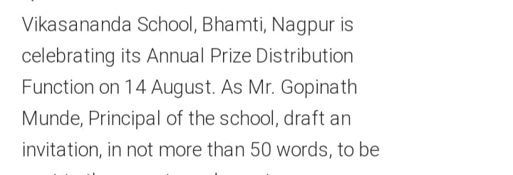
Q.2
